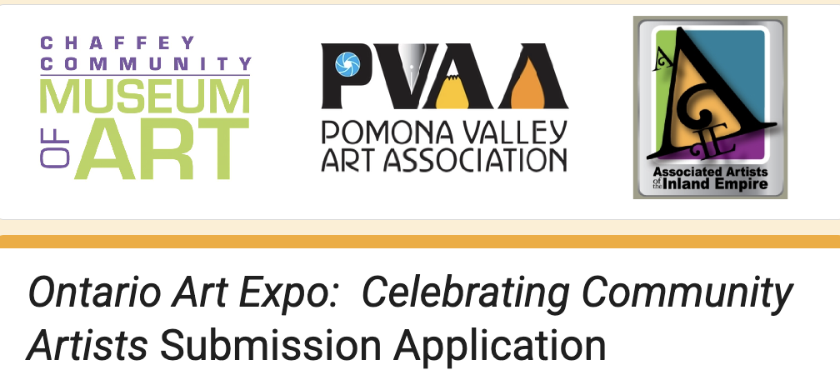
Entry Submission is June 1 through July 12
To apply, go to www.chaffeymuseum.org starting on June 1 and go to ART EXPO on the menu. Both 2D and 3D artwork will be accepted.

The Chaffey Community Museum of Art will soon be accepting entries for the upcoming Ontario Art Expo 2026: Celebrating Community Artists.

- The Exhibit will run from August 7 through October 18, but entry submission will begin on June 1 and end on July 12 at 5pm.
- Entries will only be accepted via online application.
- To learn more go to www.chaffeymuseum.org starting on June 1 and go to ART EXPO on the menu. Both 2D and 3D artwork will be accepted.
- You still have time to create something or find the perfect piece from your inventory - let's make sure and have a strong AAIE showing this year!!!

